**Happy Holidays 2016**

I can’t say I’m all that happy about 2016 in general. I’m sure I’m not alone.

The kids are thriving, though. This is the Year of High School!

Jocelyn is attending a private school, The Commonwealth School, located in Boston’s Back Bay district. She gets there on the commuter rail every day. She’s becoming very independent. She has a weekly aerial silks lesson at a circus gym, which she gets to on the subway. She has a job! She’s working at the rock climbing gym where she used to take aerial silks lessons, both helping (actually teaching!) with silks lessons, and also general work helping to run the birthday parties that are the place’s bread and butter. Generally she works about 4 hours a week, so it doesn’t cut into her studying time.

Perry is attending the local public high school. He’s doing very well, considering he hasn’t attended public school for years. He complains about his homework (what kid doesn’t), though it’s considerably less than Jocelyn’s. We’re not sure he’s appropriately placed in math, but he isn’t complaining of boredom, so I guess it’s OK. He continues his interest in computers and board games (less of the latter, though). He has recently entered a programming contest sponsored by Google. If he wins we get an all-expenses paid trip to Mountain View.

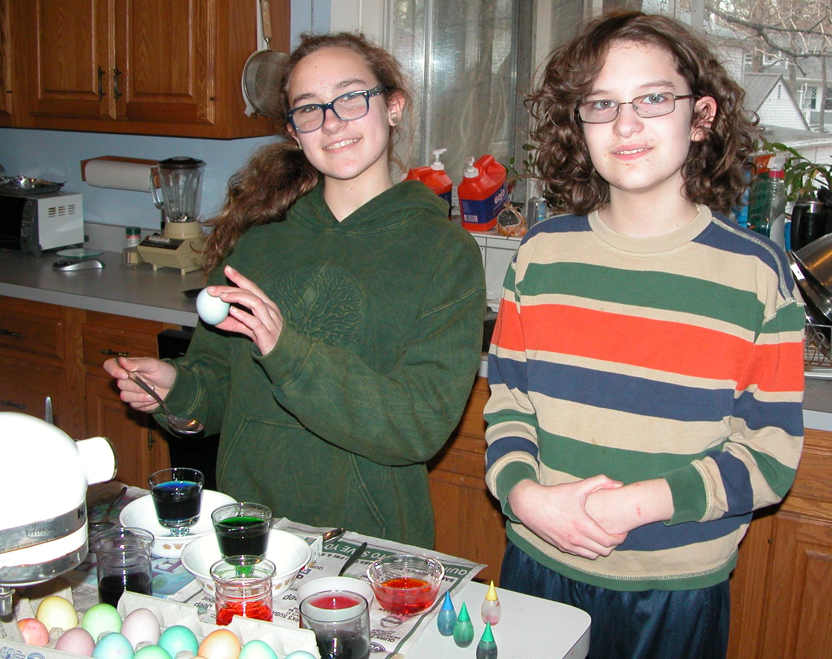

(Picture from a different holiday ☺)