Happy holidays 2011!
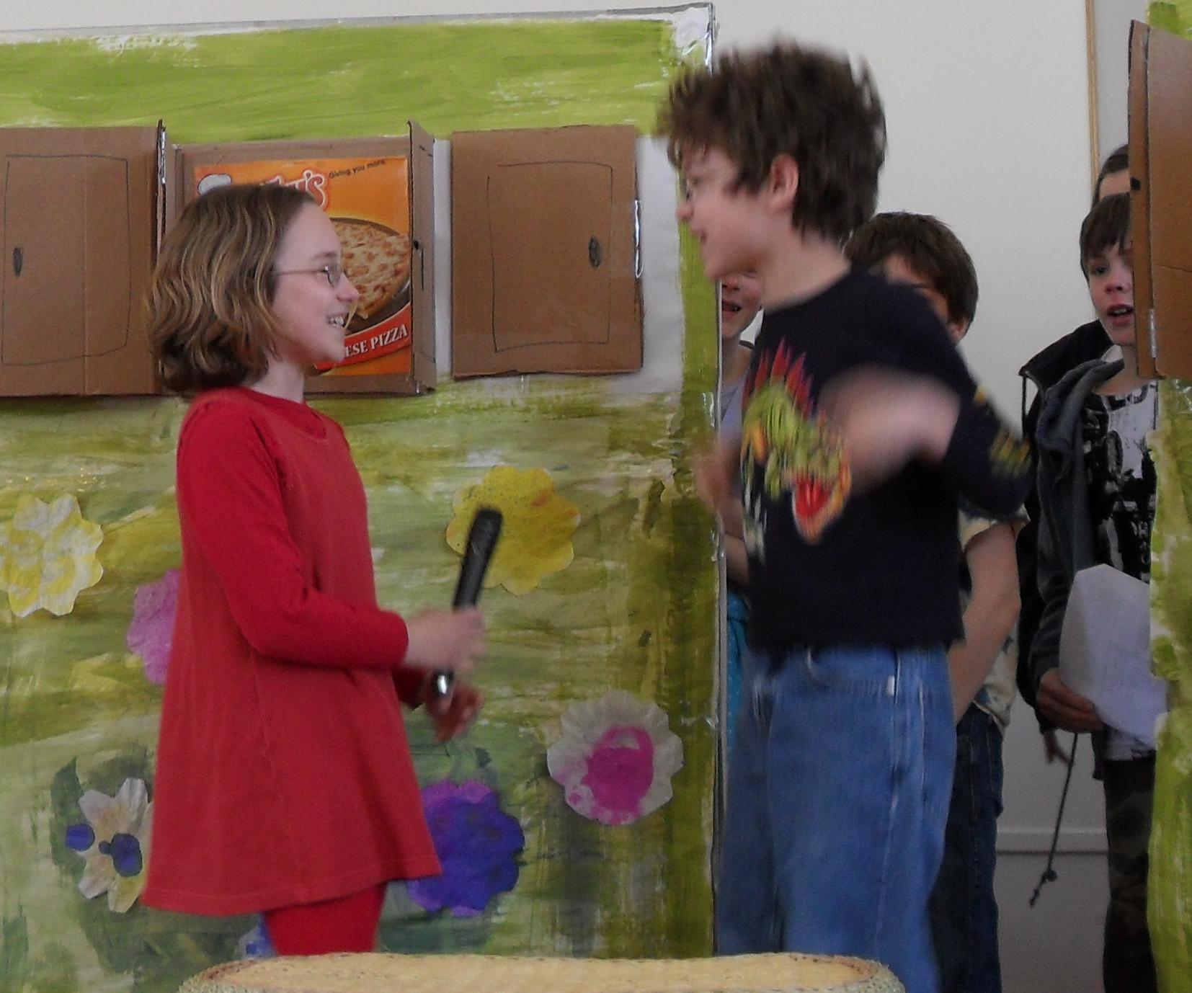
Performing in a church play

This year was a lot like last year. A lot of board game playing, too much computer use, both kids doing very well in their respective academic programs. Perry is doing advanced math and writing computer programs. Jocelyn is reading at almost adult level (we read some of the same books now) and enthusiastically gobbling up anything related to ancient history. We had another excellent European adventure, this time to Bergen, Norway, with a bonus day in Iceland and a bit of nervousness in returning due to Hurricane Irene. It was fine in the end – only a few hours delay. We had some additional excitement during a freak October snowstorm that dropped trees on power lines all over the state, and left us in the dark for three days. Our town had to delay Halloween for a week! The kids enjoyed making hot chocolate in the fireplace but everyone got tired of it after a while.

