Happy holidays 2009!

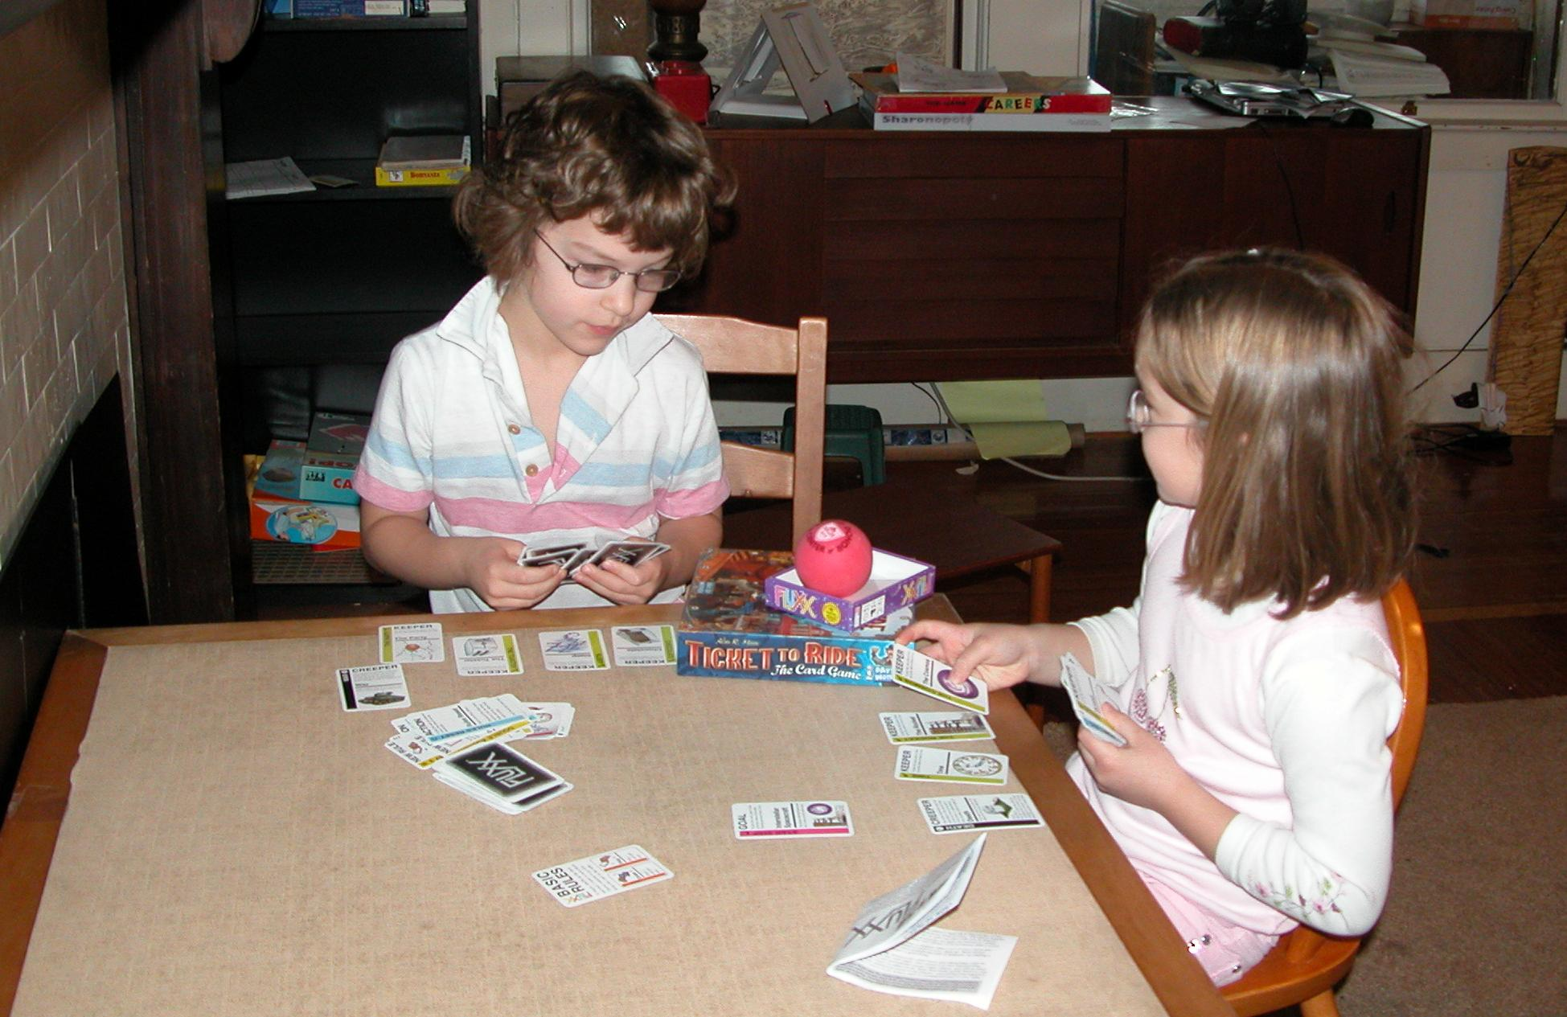

2009 was “the year of the game.” Gone are the days of Chutes and Ladders and Candyland. For a holiday gift in 2008 Perry received a copy of “Ticket to Ride,” a complex strategy board game, marked with a minimum age of a few years older. I was skeptical, but both kids rose to the occasion, understanding the rules with ease. This led to a great flurry of gaming, as we got out more and more complex games. Grownups still win more often than not, but the kids win often enough to keep them playing. Recently we’ve entered into a video-game phase, but I’m hoping this will not last, and we’ll be able to avoid limitations on “screen time” that so many parents must impose.

In other news, Perry’s school has been rearranged by the school district, so he’ll be attending a different school next year. We’re taking the opportunity to investigate various private options as well. No decision yet. Jocelyn is still doing very well at her private school, The Sage School.

