Happy New Year!

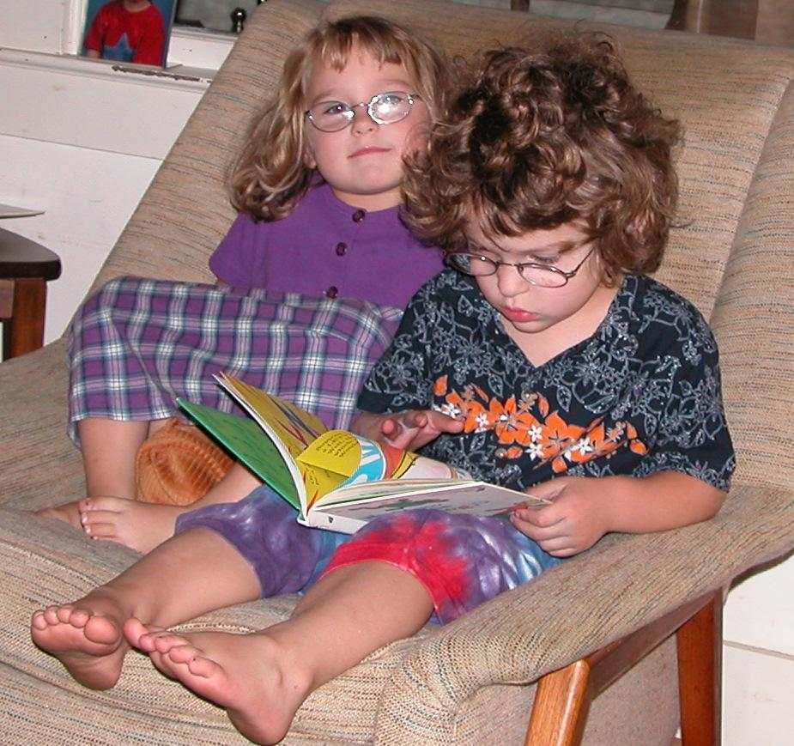
Perry reading to Jocelyn, Oct 2006

I was a little slow with the holiday letter this year…

Lots happened this year. Haircuts. Getting a pony. Many trips this summer, including one to Storyland in New Hampshire. Moving into their own bedrooms. Second year of preschool. Jocelyn loves it this year, and is quite the social butterfly. Perry learned to read. We seem to have graduated from the “Theatrical Threes” and we’re well into “Fabulous Four.”

Both of them have gone a long way on the road to self-sufficiency. They can fetch a snack and get up by themselves in the morning. Jocelyn can completely dress herself except for buckles on her shoes. Jocelyn seems to strive for self-sufficiency, while Perry assumes it only reluctantly.

We are deciding what to do for Kindergarten next fall. Our choices are a nearby private school, the regular public school, and an alternative school run by the public school system. We’ll have it sorted out by early spring.

