Happy Holidays!!

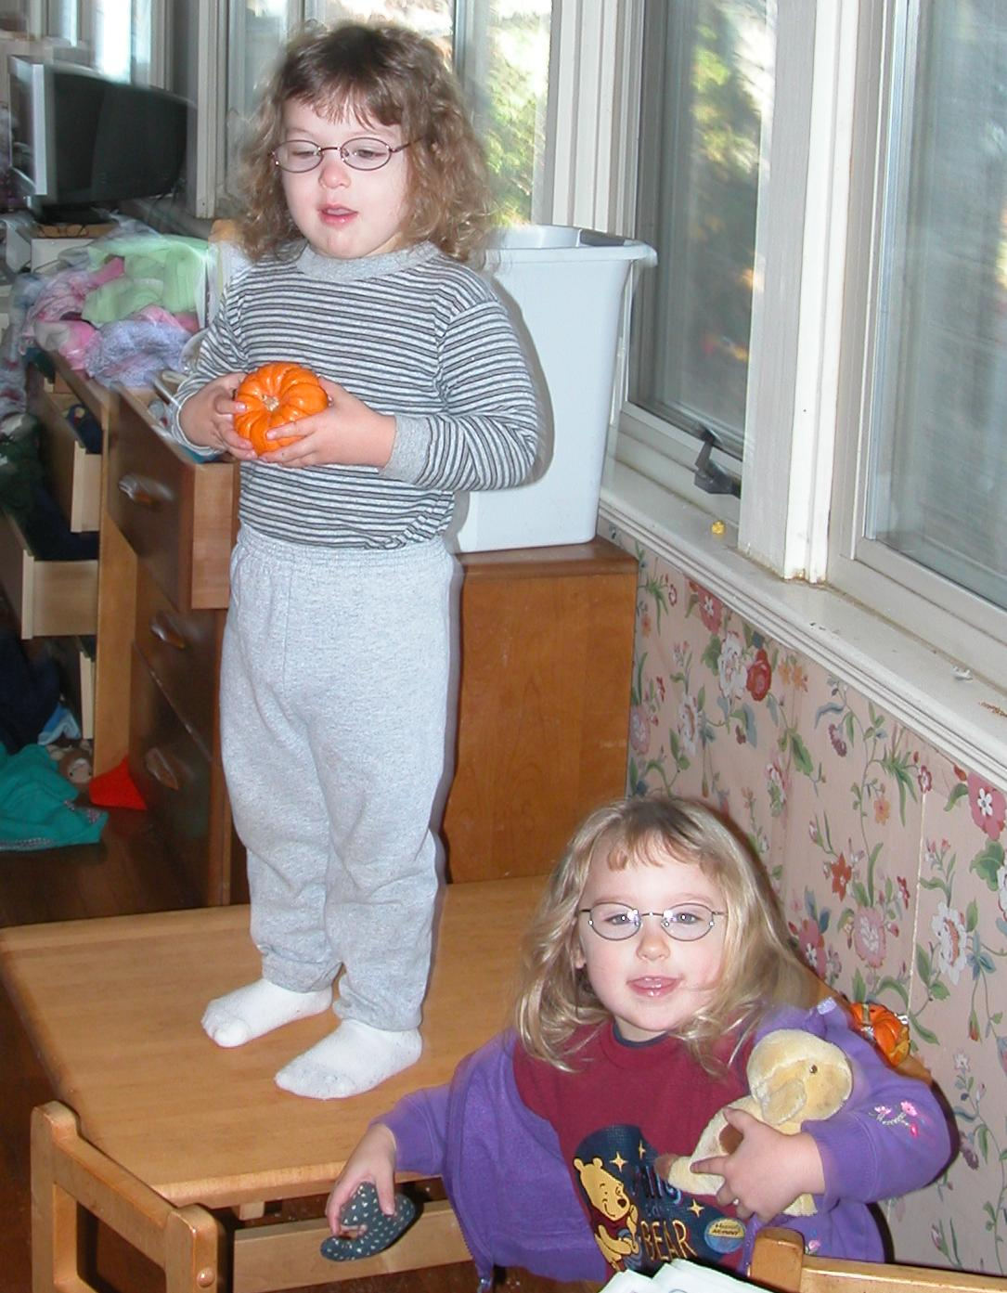

Perry proudly displays his Halloween pumpkin, with Jocelyn below.

Three and a half years old. We never had the Terrible Twos, but we’re having a bit of the Theatrical Threes. Theater of both the annoying but more often the delightful sort.

As you can see, they both have glasses, for strabismus (“lazy eye”). Jocelyn is a bit worse than Perry and has to do various eye exercise games. We’re a bit annoyed our first eye doctor didn’t get her in glasses 6 months earlier.

Perry’s in preschool, and doing very well. Jocelyn seemed to like it at the beginning, but suddenly had a change of heart, and we decided not to force the issue, so she’s staying home. This is a bit inconvenient, but we’re coping. Every once in a while she says she wants to go back, but hasn’t stuck with it. We’re just playing it by ear. We’ve been looking at a local private school for kindergarten. They have a program for 4-year-olds but it’s all day and we thought that would be a bit much.

We seem to have failed at our attempt at “non-sexist parenting”; Jocelyn loves dolls and pink and everything to do with girls, and both kids go on about “only boys” or “only girls can play with this toy”, mostly to exclude the sibling. We try to discourage this behavior/thought pattern.

