Happy Holidays!

No, they don’t really play yet – they just go through the motions. But it’s cute ☺

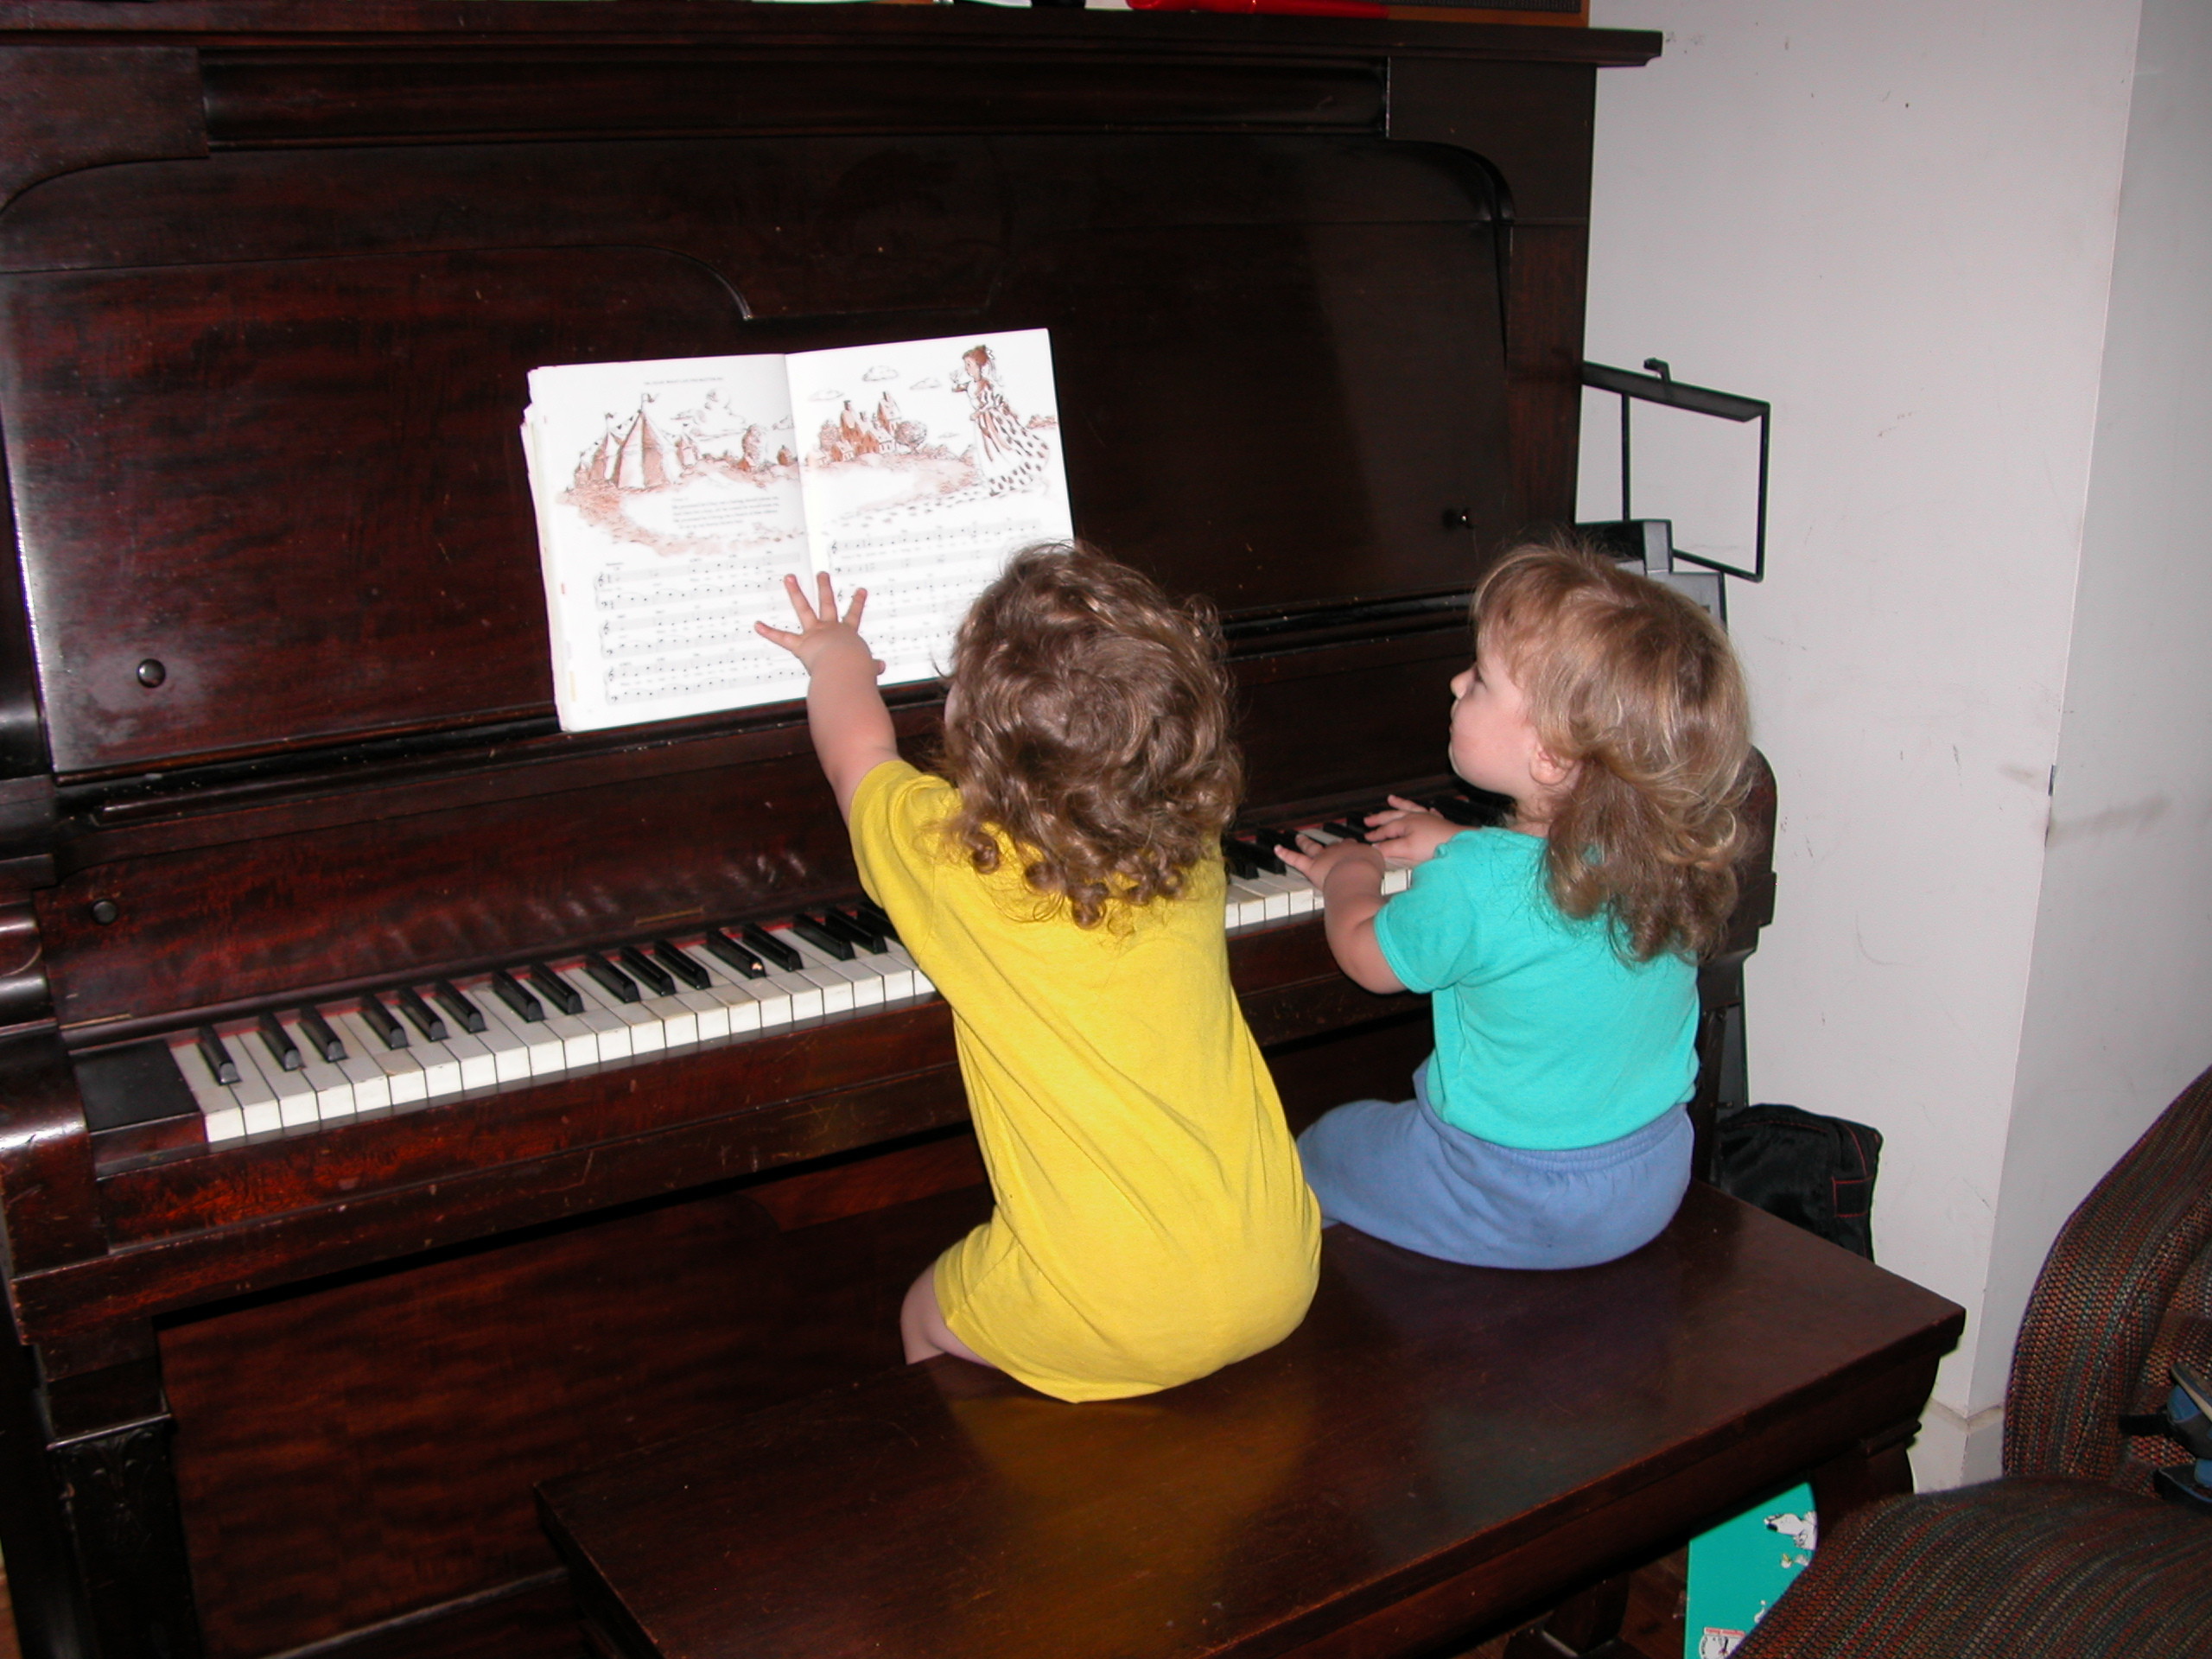

Jocelyn and Perry will be 29 months old on the Solstice. Pretty much we just say “two and a half” when asked their age. Jocelyn has an incredible imagination and amazing verbal skills. Playing pretend with her is a delight. Perry’s memorized hundreds of books and frequently treats us to recitals, at the top of his lungs, spinning in circles. Playing with him is a delight too.

No “terrible twos” for us! Just wonderful children. And I’m sure tired of hearing “well wait til they’re three then.” I just don’t believe it – everyone who says that is just jealous! Sure, there’s a little fussing now and then, but they wouldn’t be human if they didn’t fuss occasionally.

We had our first airplane trip! Trips to a local animal fair. Trips to the zoo. A car trip to Ithaca NY and Amherst MA. They’ve been busy little people! Now we’re looking at preschools to start next fall – thinking two or three mornings a week.

The kids have gotten easier to care for, but we haven’t reduced our childcare hours. So I’m working a little more – almost halftime. Ken’s back to full time. Valerie’s been writing a book and giving horse riding lessons.

It’s a busy and fun time.

